The Coversheet

Student Number  (as shown on student ID card): | 250154591
Word Count / Pages / Duration / Other Limits:
Attempt Number: | 1
Date of Submission: | 08-06-2026

I have read and understood the Academic Misconduct statement. | Tick to confirm ☒
I have read and understood the Generative Artificial Intelligence use statement. | Tick to confirm ☒
I am satisfied that I have achieved the Learning Outcomes of this assignment  (please check the Assignment Brief if you are unsure) | ​​​ Met ☒

Self-Assessment – If there are particular aspects of your assignment on which you would like feedback, please indicate below.
Optional for students
Suggested prompt questions-
How have you developed or progressed your learning in this work?
What do you feel is the strongest part of this submission?
What feedback would you give yourself?
What part(s) of this assignment are you still unsure about?

Exploring the Socioeconomic Determinants of Poverty Across the United States: A Data Visualisation Analysis (2018–2022)

LDS7004M Data Visualisation
Assessment Report

1.0 Introduction

1.1 Background
Poverty remains one of the most persistent socioeconomic challenges in the United States, affecting millions of households and influencing access to essential services such as healthcare, education, housing, and childcare. While poverty rates vary considerably across states, the factors contributing to these differences are often interconnected and complex. Understanding the underlying drivers of poverty is therefore important for policymakers, researchers, and social welfare organisations seeking to develop targeted interventions that improve economic wellbeing.
The primary objective of this analysis is to identify the key factors associated with variations in poverty levels across U.S. states, for example, one factor that has attracted increasing attention in recent years is the affordability of childcare. For many families, childcare represents a substantial household expense that directly affects employment decisions, labour force participation, and disposable income. Rising childcare costs may place additional financial pressure on low-income households, potentially increasing the risk of economic hardship and poverty. Recent evidence from the United States Department of Labor indicates that childcare costs consume a significant proportion of family income in many parts of the country, with prices varying considerably across geographical regions (U.S. Department of Labor, 2024).
To achieve the set objective, the project employs exploratory data analysis (EDA) techniques alongside multivariate visualisations to investigate relationships between poverty rates and other socioeconomic indicators. Attention is given to identifying variables that exhibit strong associations with poverty and assessing how these relationships differ across states and analysing some trends over time.
Data visualisation serves as the central analytical approach throughout the project. Effective visual representations enable complex datasets to be interpreted more intuitively, revealing trends, correlations, and geographic disparities that may not be immediately apparent through numerical analysis alone. By combining statistical exploration with visual storytelling, the project aims to communicate meaningful insights into the socioeconomic conditions that contribute to poverty across the United States.
The analysis was conducted using the Python programming language, supported by several data science and visualisation libraries, including Pandas for data manipulation, Matplotlib and Seaborn for static data visualisations, and Plotly for interactive graphical visualisation.

1.2 Dataset Selection
This project investigates the underlying insights associated with poverty rates across the United States using dataset derived from the National Database of Childcare Prices (NDCP). The NDCP is the most comprehensive federal source of county-level childcare pricing information and combines childcare market data with demographic and economic indicators, providing a valuable resource for socioeconomic analysis (U.S. Department of Labor, 2024). The dataset consists of 48,308 observations and 370 attributes.
For this study, data covering the period from 2018 to 2022 were utilised to examine patterns, trends, and relationships between poverty rates and selected economic and demographic variables.

2.0 Data Preparation and Processing

2.1 Data Cleaning
The following subsections are steps taken to preprocess and clean the dataset to ensure that;
- Only relevant variables are used in the analysis.
- There are no null values.
- There are no invalid value outliers.

2.1.1 Filtering for the Relevant Columns and Rows
A substantial proportion of these attributes are metadata fields used to indicate whether specific values were systematically imputed. For example, the variable iemr_16_state is a binary indicator identifying observations where the female employment rate was imputed. As these metadata variables do not contribute directly to the analytical objectives of this study and for the aim of aligning the dataset with the scope of the study, the dataset was subsequently filtered to remove them alongside other attributes deemed to have limited relevance to the investigation of poverty-related factors.
To ensure that the analysis focused exclusively on the most recent five-year period under investigation, only observations recorded between 2018 and 2022 were used.
Table 1: List of all the relevant variables used in this analysis
Variable Name | Description | Data Type
state_name | Name of the state | Categorical
state_abbreviation | Two-letter state abbreviation | Categorical
county_name | Name of the county | Categorical
county_fips_code | Five-digit county identifier (FIPS code) | Categorical
studyyear | Year in which the data were collected | Categorical
unr_16 | Unemployment rate of individuals aged 16 years and above | Numeric
funr_16 | Unemployment rate of females aged 16 years and above | Numeric
munr_16 | Unemployment rate of males aged 16 years and above | Numeric
mhi_2022 | Median household income (2022 USD) | Numeric
totalpop | Total population count | Numeric
h_under6_fwork | Households with children under six years old where only the father is employed | Numeric
h_under6_mwork | Households with children under six years old where only the mother is employed | Numeric
h_under6_singlem | Households with children under six years old headed by a single mother | Numeric
h_6to17_fwork | Households with children aged 6–17 years where only the father is employed | Numeric
h_6to17_mwork | Households with children aged 6–17 years where only the mother is employed | Numeric
h_6to17_singlem | Households with children aged 6–17 years headed by a single mother | Numeric
h_under6_bothwork | Households with children under six years old where both parents are employed | Numeric
h_6to17_bothwork | Households with children aged 6–17 years where both parents are employed | Numeric
mcbto5 | Median weekly full-time centre-based childcare cost (0–5 months) | Numeric
mc6to11 | Median weekly full-time centre-based childcare cost (6–11 months) | Numeric
mc12to17 | Median weekly full-time centre-based childcare cost (12–17 months) | Numeric
mc18to23 | Median weekly full-time centre-based childcare cost (18–23 months) | Numeric
mc24to29 | Median weekly full-time centre-based childcare cost (24–29 months) | Numeric
mc30to35 | Median weekly full-time centre-based childcare cost (30–35 months) | Numeric
mc36to41 | Median weekly full-time centre-based childcare cost (36–41 months) | Numeric
mc42to47 | Median weekly full-time centre-based childcare cost (42–47 months) | Numeric
mc48to53 | Median weekly full-time centre-based childcare cost (48–53 months) | Numeric
mc54tosa | Median weekly full-time centre-based childcare cost (54 months to school age) | Numeric
mcsa | Median weekly full-time centre-based childcare cost (school age) | Numeric
mfccbto5 | Median weekly full-time family childcare cost (0–5 months) | Numeric
mfcc6to11 | Median weekly full-time family childcare cost (6–11 months) | Numeric
mfcc12to17 | Median weekly full-time family childcare cost (12–17 months) | Numeric
mfcc18to23 | Median weekly full-time family childcare cost (18–23 months) | Numeric
mfcc24to29 | Median weekly full-time family childcare cost (24–29 months) | Numeric
mfcc30to35 | Median weekly full-time family childcare cost (30–35 months) | Numeric
mfcc36to41 | Median weekly full-time family childcare cost (36–41 months) | Numeric
mfcc42to47 | Median weekly full-time family childcare cost (42–47 months) | Numeric
mfcc48to53 | Median weekly full-time family childcare cost (48–53 months) | Numeric
mfcc54tosa | Median weekly full-time family childcare cost (54 months to school age) | Numeric
mfccsa | Median weekly full-time family childcare cost (school age) | Numeric
pr_p | Poverty rate of individuals | Numeric

By focusing only on variables and rows that are relevant to this analysis project, the total number of relevant rows are 16,103 and the number of variables is 40.

2.1.2 Handling Blank or Null Rows
An initial inspection of the dataset revealed a large number of missing values distributed across 22 attributes. These missing entries were imputed using the mean value calculated at the state level rather than applying a global column mean. This approach was adopted to preserve regional variation and avoid distortion that could arise from using a national average, particularly for states with significantly different population sizes or socioeconomic characteristics.
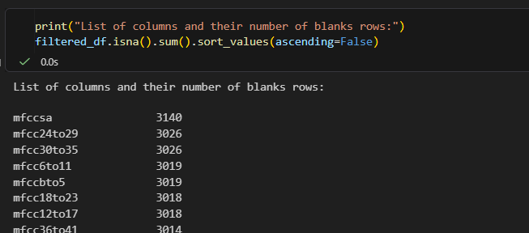
Figure 1: Code screenshot showing the top attributes with the highest number of blank rows
For the remaining attributes where missing values persisted after the initial imputation step, the absence of data indicated that no county-level records were available for those numerical variables across all years within the respective states. These remaining gaps were filled using the national median for each variable to maintain consistency while reducing the influence of extreme values, which could otherwise distort the dataset if the mean were used.
Figure 2: Code screenshot showing the process of using a reusable function to fill the remaining blank cells wit national averages

2.2 Feature Engineering

2.2.1 Merging related attributes in the dataset
New variables were created by combining related attributes that were analysed collectively. For example, the variables representing the number of households where both parents were working were originally recorded across different child age-group categories. These age-specific values were therefore merged into a single variable to produce an overall measure. Some related attributes were aggregated with the mean and some were merged with the sum aggregate function depending on what was statistically appropriate.
After merging, the related attributes were no longer needed and were dropped from the dataset.
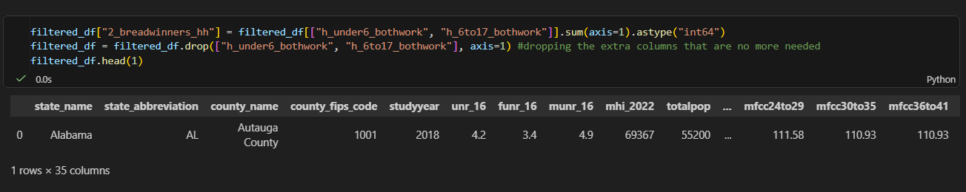
Figure 3: Showing how the total number of two-breadwinner households was derived from adding two related attributes

2.2.2 Deriving the Poverty Population Attribute
A new variable, poverty_population, was created to represent the total number of individuals living below the poverty line within each county. This measure provides a more concrete indication of poverty levels by accounting for population size. It also supports the computation of more reliable poverty rates at both state and national levels.
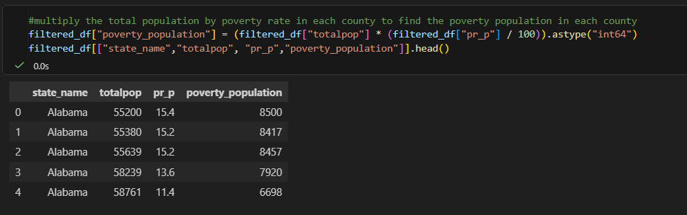
Figure 4: Calculating the poverty_population attribute by multiplying the total population with the poverty rate in each County

2.2.3 Dropping Redundant Variable
The general unemployment rate variable (unr_16) was removed from the dataset because it can be indirectly derived from the gender-specific unemployment rate variables.
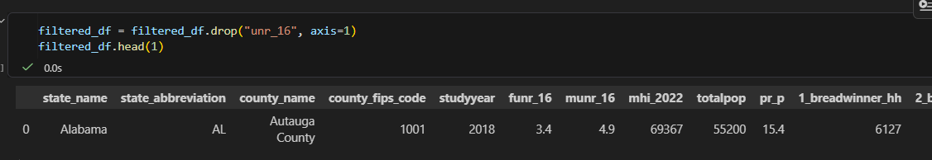
Figure 5: Dropping derivable attribute to reduce redundancy

2.2.4 Finalising the Dataset
To conclude the feature engineering process, the following attributes were renamed for better clarity during analysis.
Table 2: Renaming Applied during Data Processing
Original Variable Name | New Variable Name
funr_16 | female_unemployed_rate
munr_16 | male_unemployed_rate
mhi_2022 | 2022_med_household_inc
pr_p | poverty_rate
Upon concluding the data processing steps, the final cleaned dataset contained 16,103 observations and 15 attributes prepared for analysis.
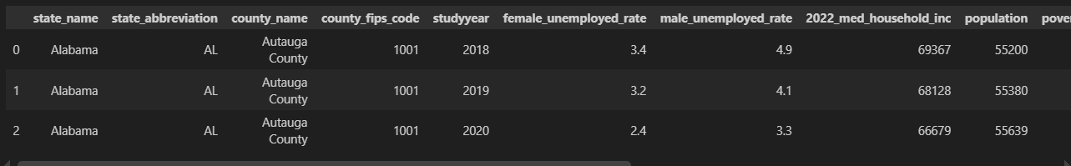
Figure 6: Preview of the final dataset
The cleaned dataset was exported into memory for future usage or external usage.

3.0 Performing Exploratory Data Analysis

3.1 Summary Statistics and Initial Observations
The Pandas describe() function was used to summarise the dataset to show the central tendency summary of each numerical variable as shown in Figure 7.
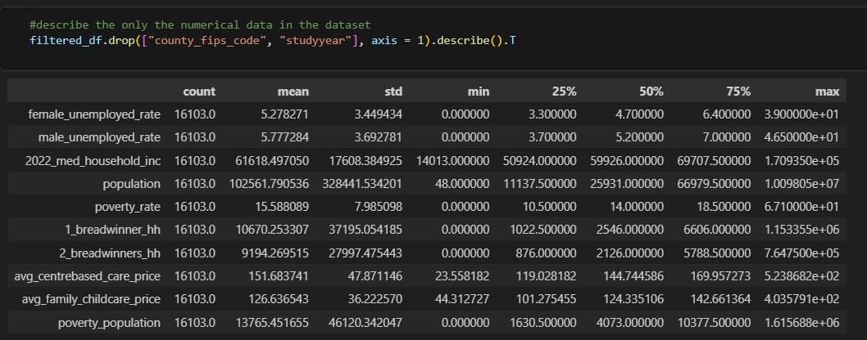
Figure 7: Summary statistics of all numerical variables in the dataset
Insights from the summary statistics:
The descriptive statistics provided an initial overview of the distribution and variability of the selected variables.
- The unemployment rates for both males and females exhibited evidence of high-end extreme values. Although the mean and median unemployment rates were approximately 5%, and 75% of observations recorded unemployment rates below 7%, the maximum values exceeded 35%. While these observations may be considered outliers, they likely reflect genuine economic conditions within certain counties and were therefore retained for further analysis.
- The standard deviation of the 2022 median household income indicated substantial variation in income levels across U.S. counties, suggesting notable economic disparities between regions.
- The distribution of poverty rates also contained several extreme observations. Although 75% of counties recorded poverty rates below 18.5%, some counties exhibited poverty rates exceeding 65%. These values were preserved as they represent meaningful variations within the dataset and are relevant to the objectives of the study.
- The variability observed in both centre-based and family childcare costs was relatively high when compared with their respective mean values. This suggests substantial differences in childcare affordability across the United States.
- No invalid values were identified during the review of the summary statistics. In particular, no negative values or other implausible observations were detected within the numerical variables, indicating that the data was suitable for further analysis.

3.2 Examination of Variable Distributions and Visualising Outliers
Outliers were treated differently in this study because the objective was to examine actual socioeconomic conditions across all U.S. states, including observations with unusually high values that represent legitimate records. To assess their impact and understand the distribution of each numerical variable, histograms were used to visualise their spread and shape.
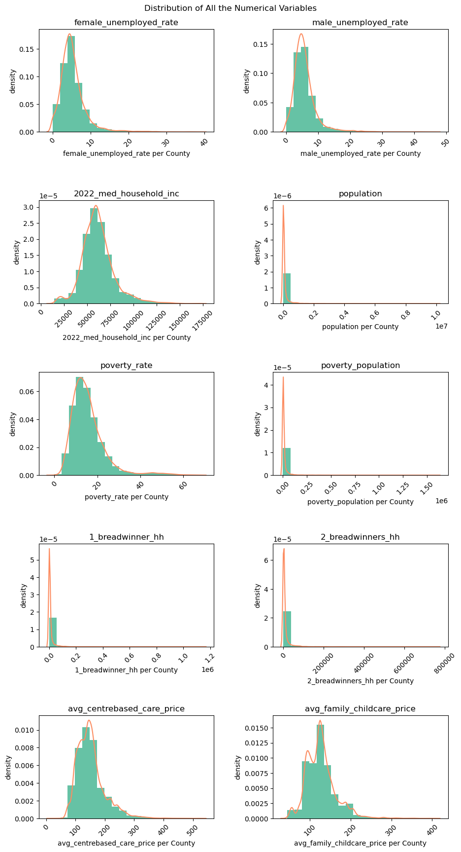
Figure 8: Subplots of histograms showing the spread of each numerical variable in the dataset
The histograms and kernel density estimates indicated that most variables followed approximately normal distributions, although they all exhibited positive skewness where majority of the population are on the lower end. For example, variables such as unemployment rates for each gender, poverty rate, population, and child-care price variables were characterised by a concentration of observations at lower values, accompanied by a relatively small number of counties with exceptionally high values. These extreme observations contributed to the long right tails observed in the distributions and reflect substantial variation across U.S. counties.

3.3 Analysing the Correlation between the Numerical Variables
A correlation heatmap was selected to visualise relationships between the numerical variables in the dataset because it provides a compact and intuitive overview of pairwise associations within large multivariate data. A heatmap enables simultaneous comparison of all correlations in a single visual structure, improving interpretability and analytical efficiency. This makes it particularly useful for identifying patterns such as multicollinearity, strong positive or negative relationships, and weak or insignificant associations across socioeconomic indicators (Wilkinson and Friendly, 2009).
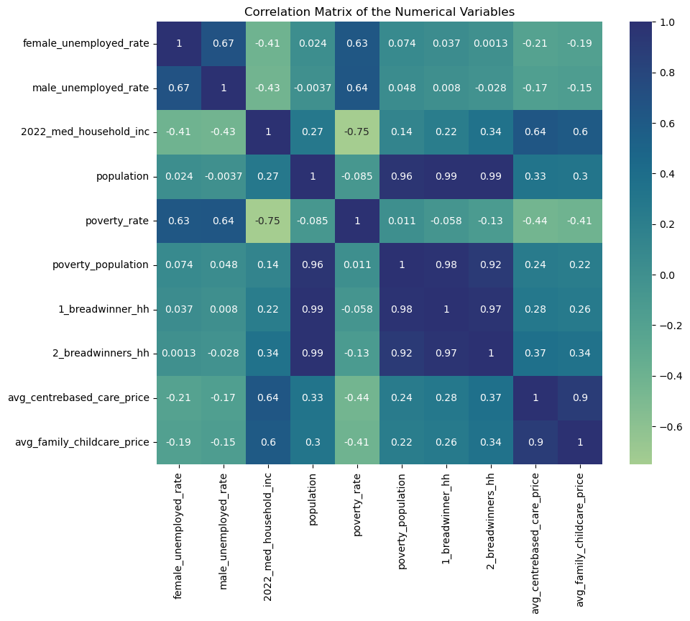
Figure 9: Heatmap visualising correlation scores of all the numerical variables.

3.3 Analysing the Unemployment Rate Variable as a Key Determinant of Poverty Rate
The examination of the unemployment rate variable as a key determinant of poverty rate revealed that Guánica County recorded the highest male unemployment rate at 46.5% in 2020, while Utuado County exhibited the highest female unemployment rate at 39% in 2020. Both counties are in the State of Puerto Rico.
At the lower end, approximately thirty-five counties reported a 0% unemployment rate. A large proportion of these counties are characterised by very small population sizes.
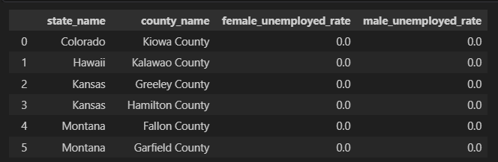
Figure 10: Preview of the Counties with the lowest unemployment rates reported in the dataset in the United States
Furthermore, by examining the full five-year trend in annual unemployment rates, the bar chart in Figure 11 illustrates a steady decline in unemployment in the United States of America between 2018 and 2022, reaching its lowest level in 2022 at 5.13%. A bar chart was chosen for this visualisation because it provided a clear and effective way of comparing discrete values across different years, allowing trends over time to be easily identified without visual clutter.
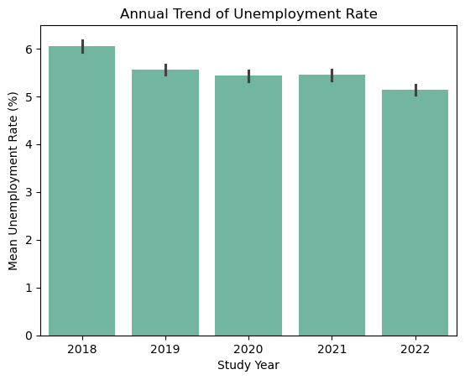
Figure 11: Bar chart showing the annual trend of unemployment rate in the United States of America
Comparing each gender, the pie chart in Figure 12 indicates that unemployment rates are slightly higher among males compared to females in the United States, accounting for 52.26% and 47.74% respectively. The pie chart visualisation method was chosen because it was most effective for showing part-to-whole relationships when the number of categories is limited. Pie Chart improves interpretability and reduces visual complexity (Few, 2012).
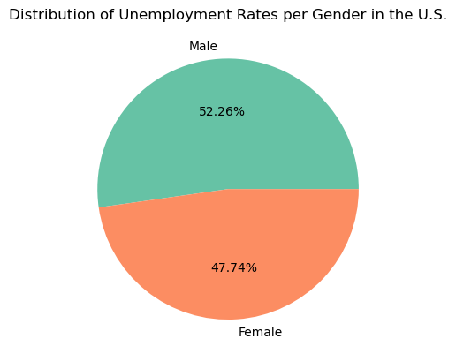
Figure 12: Pie chart comparing the unemployment rates of both gender across five (5) years

3.4 Analysing the Relationships Between Other Variables with High Correlation Scores
To enable the visualisation of correlation between two or three variables, reusable functions were created to make the plotting a scatter plot and making annotation faster to reduce repetitive code in the notebook..
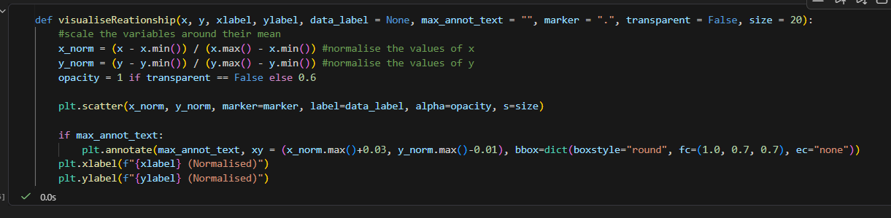
Figure 13: A reusable function for plotting scatter plot and making annotation on it. For showing relationship between 2 or 3 variables
Another similar reusable function was created for plotting 2D Kernel Density Estimation plot for analysis.

3.4.1 Visualising the Data-Points of Centre-Based Care Prices and Family Child-Care Prices for each State County
The examination of the unemployment rate variable as a key determinant of poverty rate revealed that Guánica

